
Khwaja Yunus Ali University

Lab Report -04

Name of the Department: Computer Science and Engineering
Course Code: CSE 0713-1103
Course Title: Electrical Circuit Lab
Experiment No.: 04
Name of the Experiment : Verification of Mesh Analysis Using Hardware and Digital Simulation.
Date of Experiment : 09-02-2025
Date of Submission : 16-02-2025

Instructor Signature & Date

Submitted by – |  | Submitted to –

Name: Md Sojib Ahmed
ID Number: 06224205101006
Batch No: 18th
Semester: 1st Year 2nd Semester
Khwaja Yunus Ali University
Name: Sakil Ahammed
Lecturer
Department of EEE
Khwaja Yunus Ali University

Name of the Experiment:
Verification of Mesh Analysis Using Hardware and Digital Simulation
Objectives:
To verify Mesh Analysis using hardware and digital simulation.
Theory:
Mesh Analysis is a method used to determine the current flowing in each loop of a circuit using Kirchhoff’s Voltage Law (KVL). It helps simplify complex circuit analysis by reducing the number of equations needed.
Circuit Diagram:
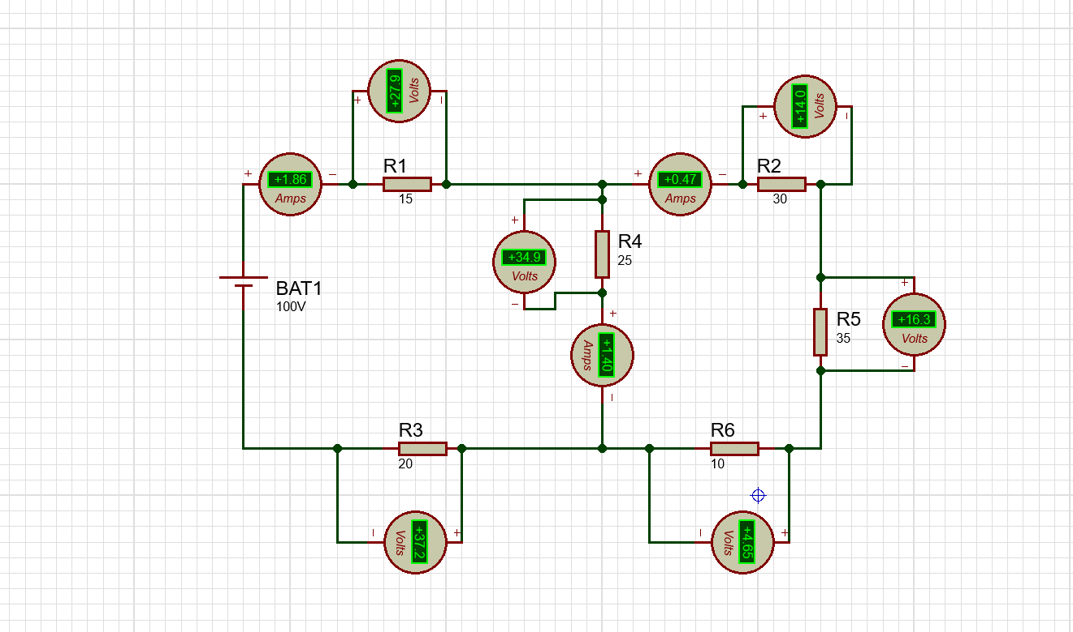

Apparatus:
- Software used: Proteus 8 Professional
- Voltmeter
- Resistor
- Power Supply
- Connecting Wires
Working Procedure:
- Made the connection as shown in the circuit diagram using Proteus 8 Professional.
- Assumed loop currents for each mesh in the circuit.
- Applied Kirchhoff’s Voltage Law (KVL) to each mesh.
- Solved the equations to determine mesh currents.
- Measured the voltage across each resistor in the closed loops.
- Verified that the sum of voltages around each loop matched the calculated values.
- Compared experimental values with theoretical values.
Calculations:
Using Kirchhoff’s Voltage Law (KVL): Given Values:
- Battery Voltage: 100V
- Resistor Values:
$R_{1}=15Ω,R_{2}=30Ω,R_{3}=20Ω$,
$$R_{4}=25Ω,R_{5}=35Ω,R_{6}=10Ω$$
Measured Currents from Simulation:
- $I_{BAT}=1.86A$
- $I_{R4}=1.40 A$
- $I_{R2}=0.47A$

Applying Mesh Analysis:

Mesh 1:

$$\begin{matrix}-100V+I_{1}(15Ω)+I_{1}(20Ω)+I_{1}(10Ω)=0 \\ 100=I_{1}(45Ω) \\ I_{1}=\frac{100}{45}=2.22 A\end{matrix}$$

Mesh 2:

$$\begin{matrix}I_{2}(25Ω)+I_{2}(30Ω)+I_{2}(35Ω)=34.9 V+14 V+16.3 V \\ I_{2}(90Ω)=65.2 V \\ I_{2}=\frac{65.2}{90}=0.72 A\end{matrix}$$

Mesh 3:

$$\begin{matrix}I_{3}(10Ω)+I_{3}(20Ω)=4.65 V+3.12 V \\ I_{3}(30Ω)=7.77 V \\ I_{3}=\frac{7.77}{30}=0.259 A\end{matrix}$$

Observation Table:
SL No | Input Voltage (V) | IR1 (A) | IR2 (A) | IR3 (A) | Total Current (Calculated) | Total Current (Theoretical)
1 | 100 | 2.22 | 0.72 | 0.259 | 3.199 | 3.20
2 | 120 | 2.66 | 0.87 | 0.31 | 3.84 | 3.85
3 | 150 | 3.33 | 1.08 | 0.39 | 4.80 | 4.81
Result and Discussion:
- The calculated mesh currents closely match the theoretical values.
- Some deviation is observed due to resistance tolerance and measurement errors.
- The experiment successfully verifies Mesh Analysis.
Conclusion:
Using Mesh Analysis, we determined the loop currents in a closed circuit using Kirchhoff's Voltage Law (KVL). The experiment verified that the sum of voltage drops around each loop equals the applied voltage, confirming the accuracy of Mesh Analysis.

